

TA’S Project



**PAAREES PERFUMES**

**zzayesha, HADIA, SADIA**



**(ePROJECt)**

**PAARESS PERFUMES WEBSITE**

**BY**

**SHAYAN JUNAID**

**HASNAIN**





**CERTIFICATE OF COMPLETION**

This is to certify that this project entitled “PAARESS PERFUMES” submitted in partial fulfillment of the TA Project completed by

Signature: ________________________



INDEX



1. *Introduction*
2. *Dedication*
3. *Acknowledgement*
4. *About E-project*
5. *Project Objective*
6. *Problem Statement*
7. *Project Requirement*
8. *Screen Shots*
9. *Task Sheets*

*10. Thank You*



# introduction:

*The thirst for learning, upgrading technical skills and applying the concepts in real life environment at a fast pace is what the industry demands from IT professionals today. However busy work schedules, far-flung locations, unavailability of convenient time-slots pose as major barriers when it comes to applying the concepts into realism. And hence the need to look out for alternative means of implementation in the form of laddered approach.*

*The above truly pose as constraints especially for our students too! With their busy schedules, it is indeed difficult for our students to keep up with the genuine and constant need for integrated application which can be seen live especially so in the field of IT education where technology can change on the spur of a moment. Well, technology does come to our rescue at such times!!*

*Keeping the above in mind and in tune with our constant endeavour to use Technology in our training model, we at Aptech have thought of revolutionizing the way our students learn and implement the concepts using tools themselves by providing a live and synchronous eProject learning environment!*



# 

**dedication**:

*I dedicate this humble piece of work to my beloved*

**“parents & relatives”**

*Who have not only supported me but also appreciated us.*

*I dedicate this project to my respectable, sincere*

“**TEACHER”**

**MISS: ARSHIA ABDUL MUNAF**

**aknowledgement**



*We are very thankful to Dear Almighty ALLAH by his grace I was able to complete this task.*

*I would like to acknowledge all who helped and guide me all the way to finish this task.*

*I am really grateful because I managed to complete my E-project within the time given by our teacher* ***Miss Arshia****. This assignment cannot be completed without the effort.*

*I also sincerely thank our teacher* ***Sir Tayyab*** *for the guidance and encouragement in finishing this project and also for teaching us in this course.*

*Last but not the least, I would like to express my gratitude to our friends and respondents for the support and willingness directly or indirectly to spend some times with us to fill in the questionnaires.*

**So what is this eproject?**

**So what is this eProject?**

*eProject is a step-by-step learning environment that closely simulates the classroom and Lab based learning environment into actual implementation. It is a project implementation at your fingertips!! An electronic, live juncture on the machine that allows you to*

* *Practice step by step i.e. laddered approach.*
* *Build a larger more robust application.*
* *Usage of certain utilities in applications designed by user.*
* *Single program to unified code leading to a complete application.*
* *Learn implementation of concepts in a phased manner.*
* *Enhance skills and add value.*
* *Work on real life projects.*
* *Give a real life scenario and help to create applications more complicated and useful.*
* *Mentoring through email support.*

*The students at the centre are expected to complete this eProject and send complete project along with the documentation to eProjects Team*

*Looking forward to a positive response from your end!!*

# Objectives of the project

***Objectives of the project***

*The Objective of this program is to give a sample project to work on real life projects. These applications help you build a larger more robust application.*

*The objective is not to teach you JavaScript/Dreamweaver but to provide you with a real-life scenario and help you create basic applications using the tools.*

*You can revise the chapters before you start with the project.*

*This project is meant for students who have completed the module of* ***Dreamweaver****. These programs should be done in the Lab sessions with assistance of the faculty if required.*

*It is very essential that a student has a clear understanding of the subject. Students should go through the project and solve the assignments as per requirements given.*

*Kindly get back to eProjects Team in case of any doubts regarding the application or its objectives.*

# 

**PROBLEM statement**

***Problem Statement***

Paarees Perfumes is selling various Perfumes from different brands. The company advertises by distributing the pamphlets, advertising on television and so on. Due to rapid development in internet field, the company decides to launch a website where people will get all the information about the various products available with them easily.

**Requirement Specification:**

The Web site is to be created based on the following requirements.

1. The Home Page should be created with proper sections, graphics and with a suitable logo
2. The site should display a menu which will contain the options for brief introduction about the various products available, location of the shop and any other information if required.
3. The information should be categorized according to different brands like if a User wants to see only ‘Davidoff Perfumes’ then he click on a Link/button/menu etc and he will see all Davidoff Perfumes. Similarly for ‘Dior’, ‘CK’ and other brands.
4. User can choose between Ladies, Gents or Common Perfumes.
5. A brief summary of details of individual products should be displayed on the Web Page along with the product but detailed Features should be stored in Individual Word documents which can be downloaded or viewed by the User who wishes to see the same.
6. Price List should be available for download.
7. There should be a “Contact Us” page which will have the Address of the Company which is as follows and the mail address which when clicked will invoke the local mail client from where they can send an email.



**HARDWARE / SOFTWARE REQUIREMENTS**

***Hardware/ Software Requirements***

**Hardware**

* *A minimum computer system that will help you access all the tools in the courses is a Pentium 166 or better*
* *64 Megabytes of RAM or better*.

**Software**

* *Notepad/HTML editor*
* *Dreamweaver*
* *IE 5.0/ Netscape 6.0*



# SCREEN SHOTs

****HOME PAGE**



# *HOME PAGE SOURCE CODE*

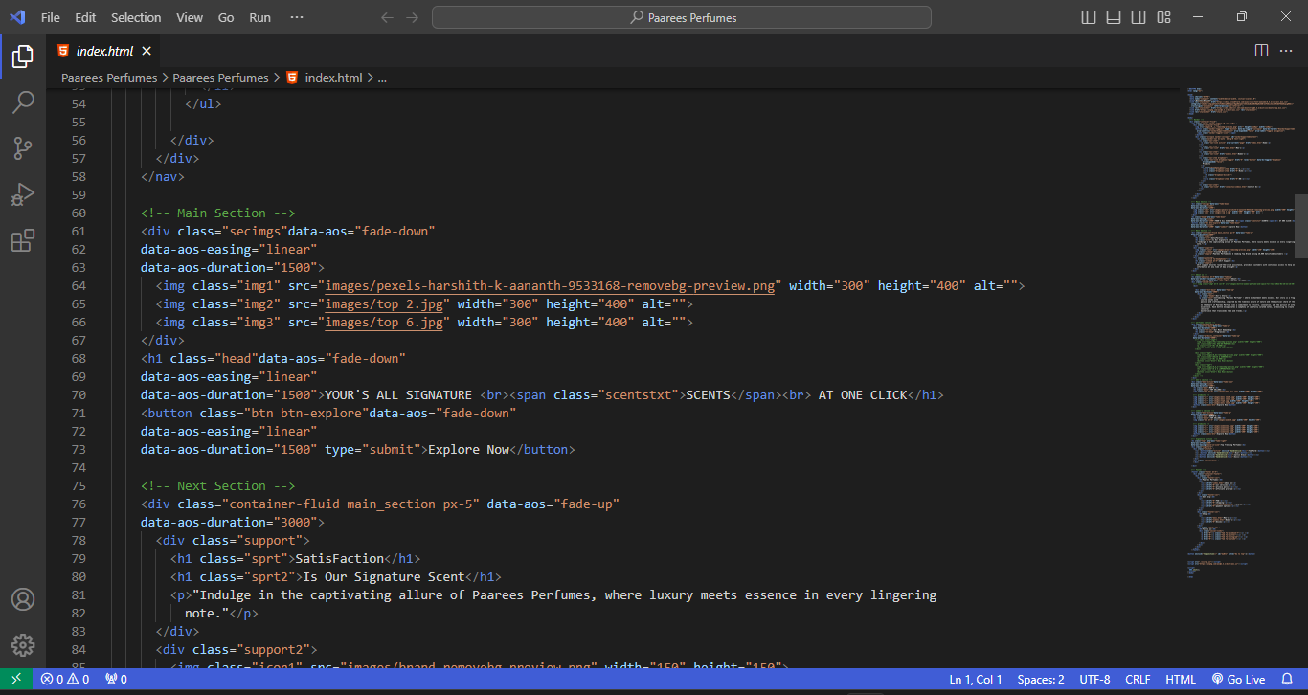

LOGO AND HEADERS DETAILS

* We have designed Logo from Canva.

***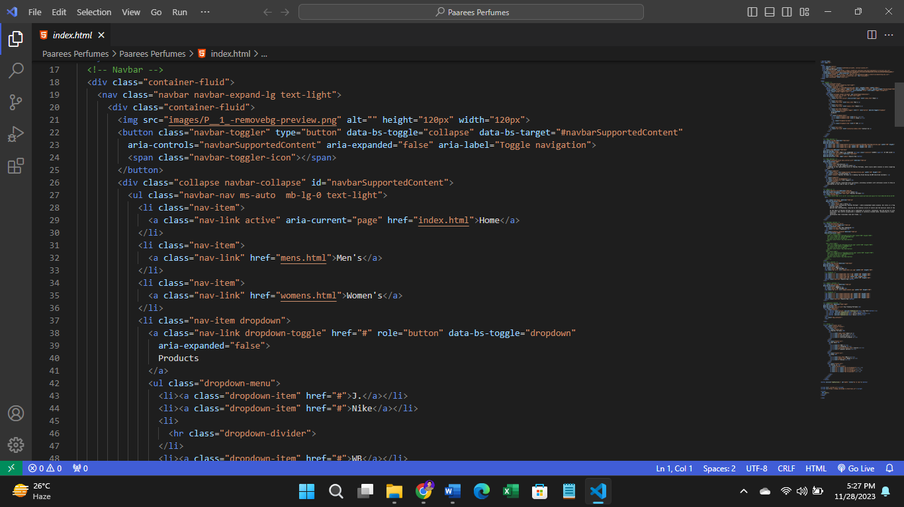****NAVIGATION BAR*

*NAVIGATION BAR SOURCE CODE*

**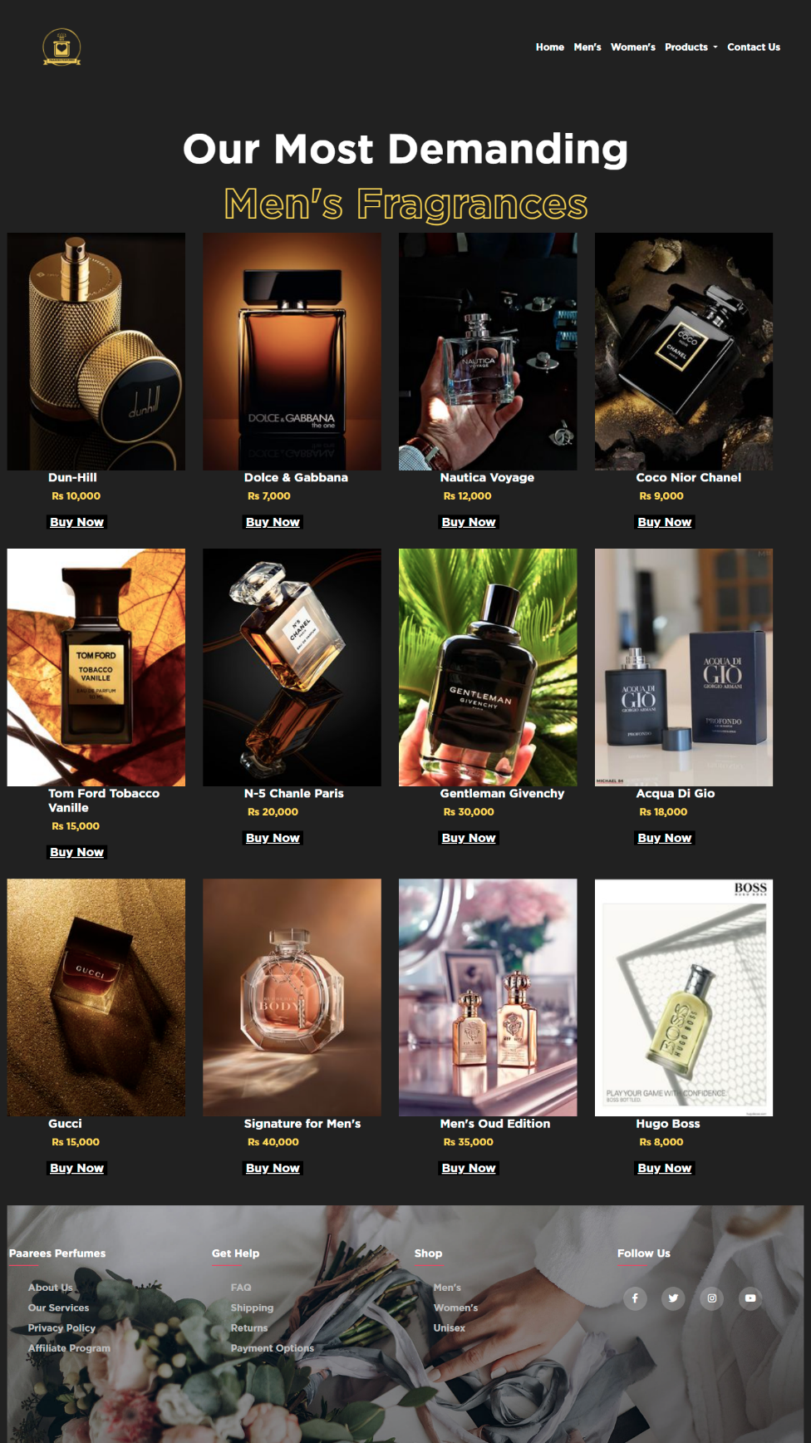***MEN’S SECTION*



*MENS’ SECTION SOURCE CODE*

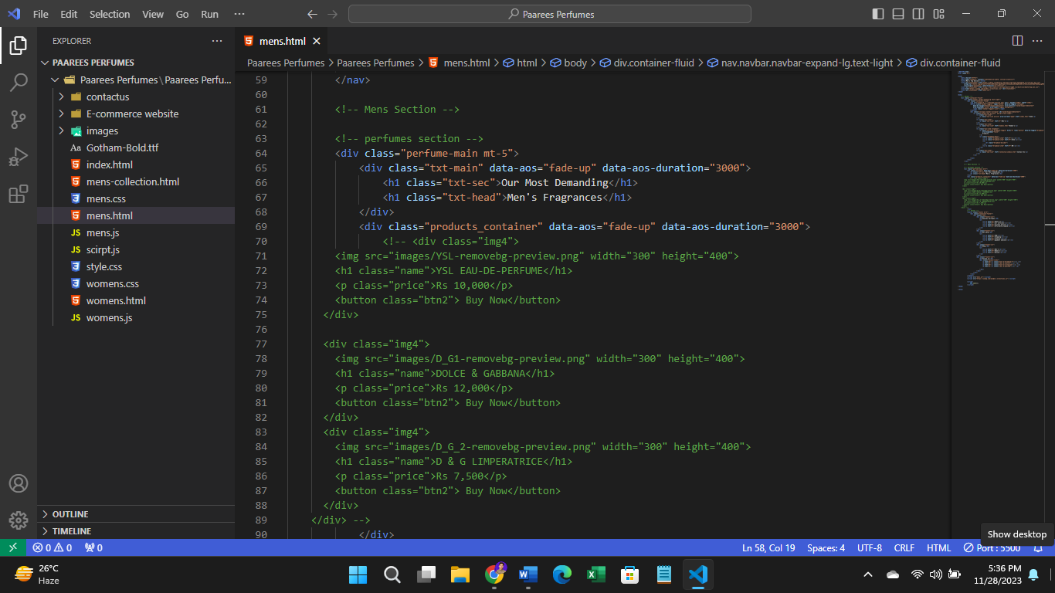

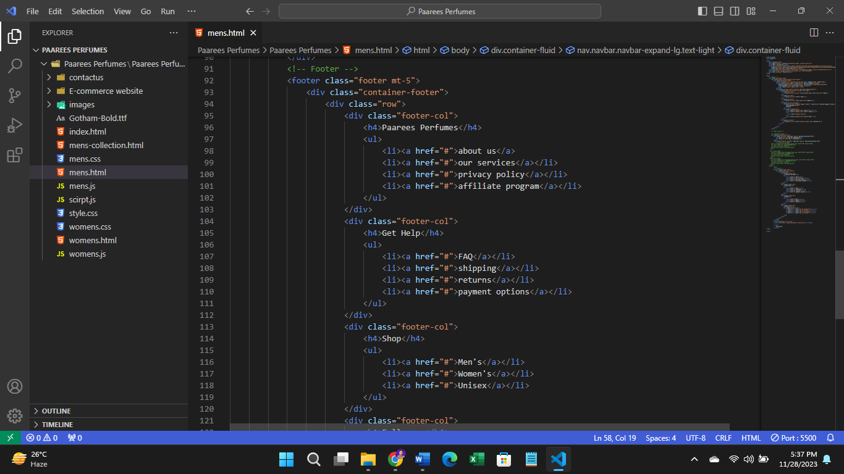



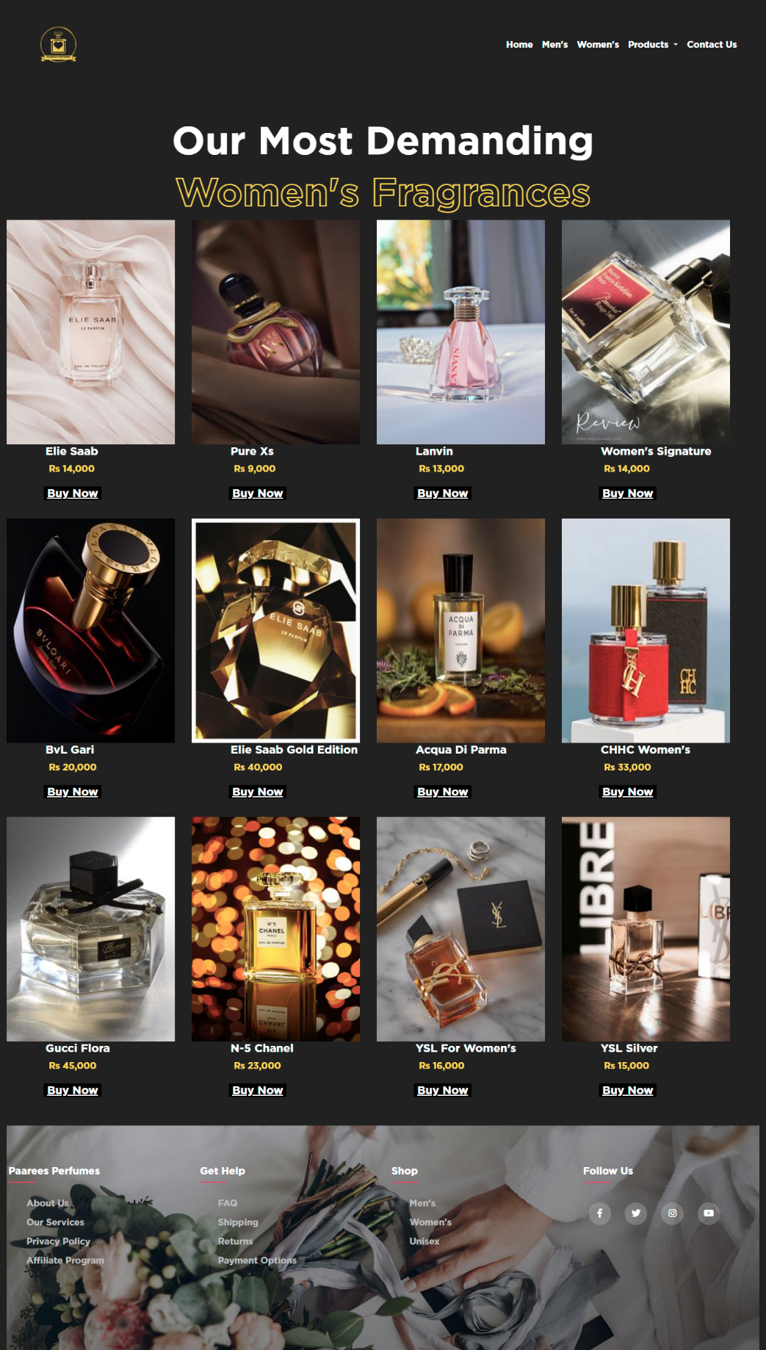*WOMEN’S SECTION*



**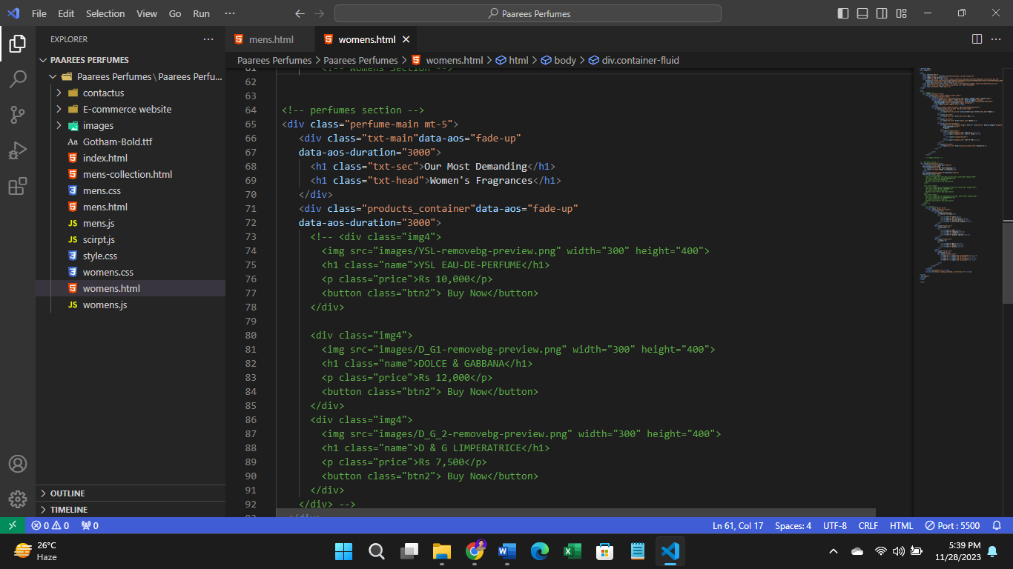***WOMEN’S SECTION SOURCE CODE*



**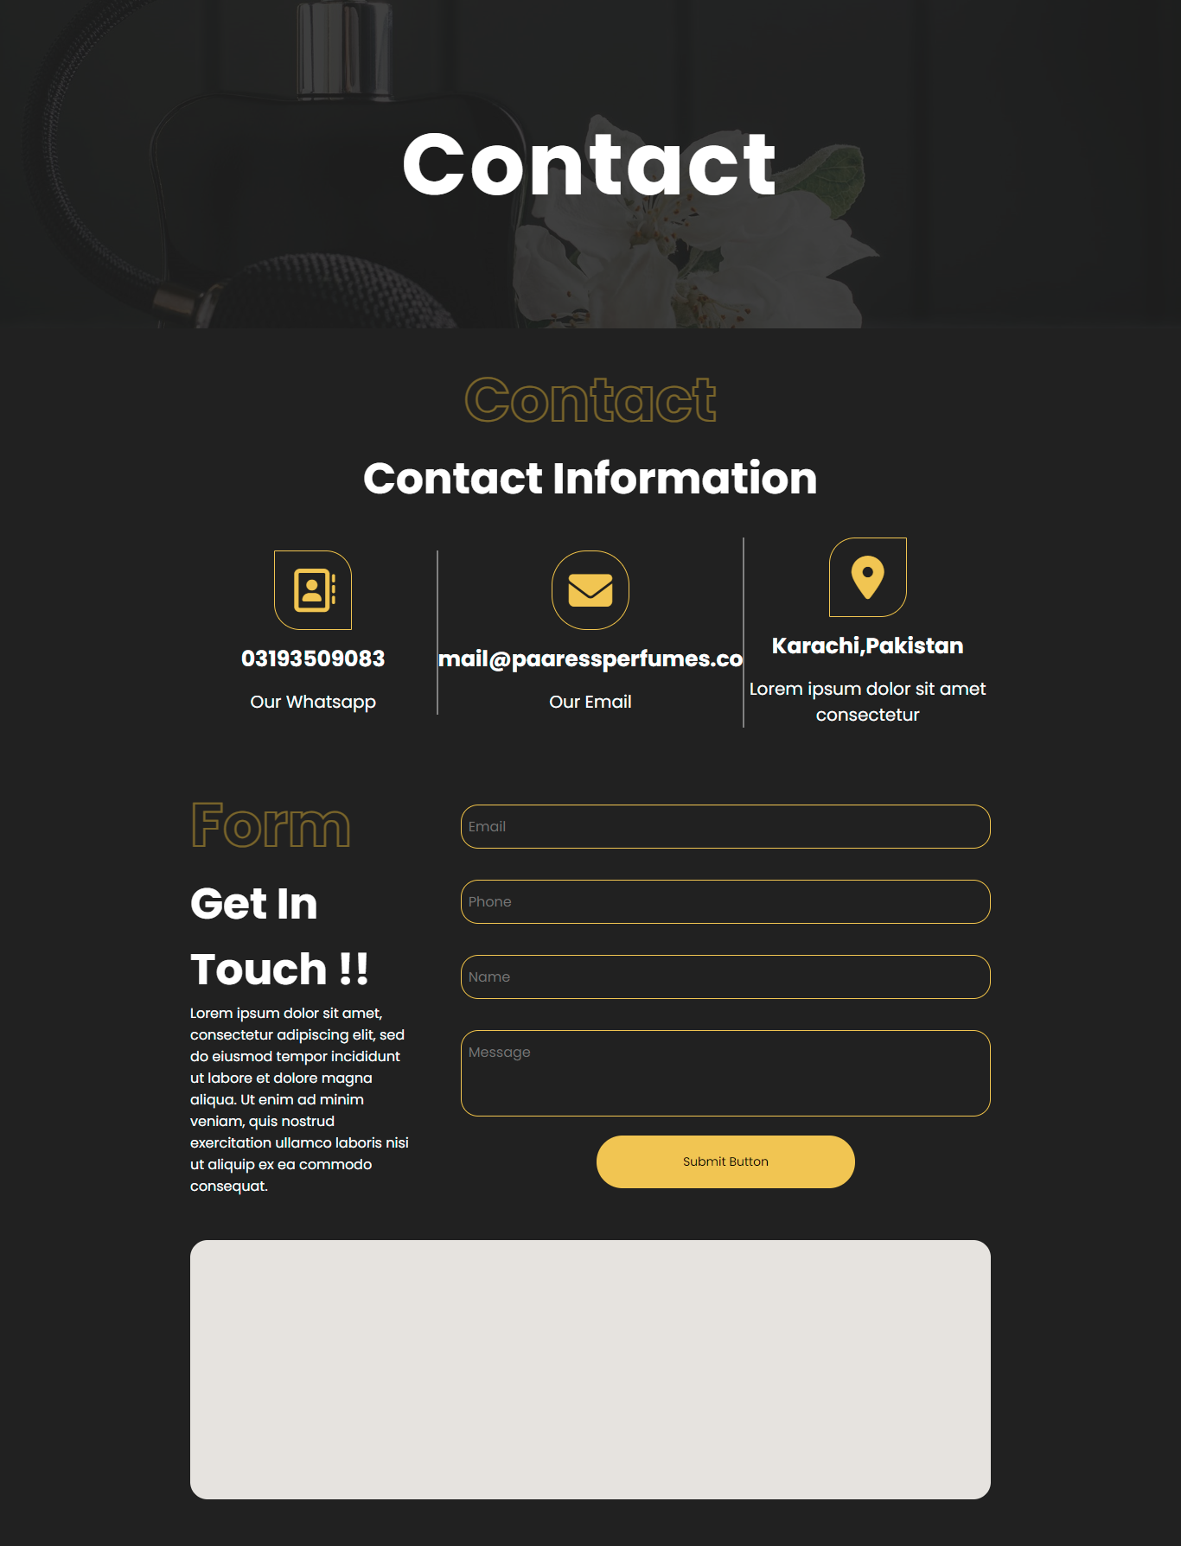***CONTACT PAGE*

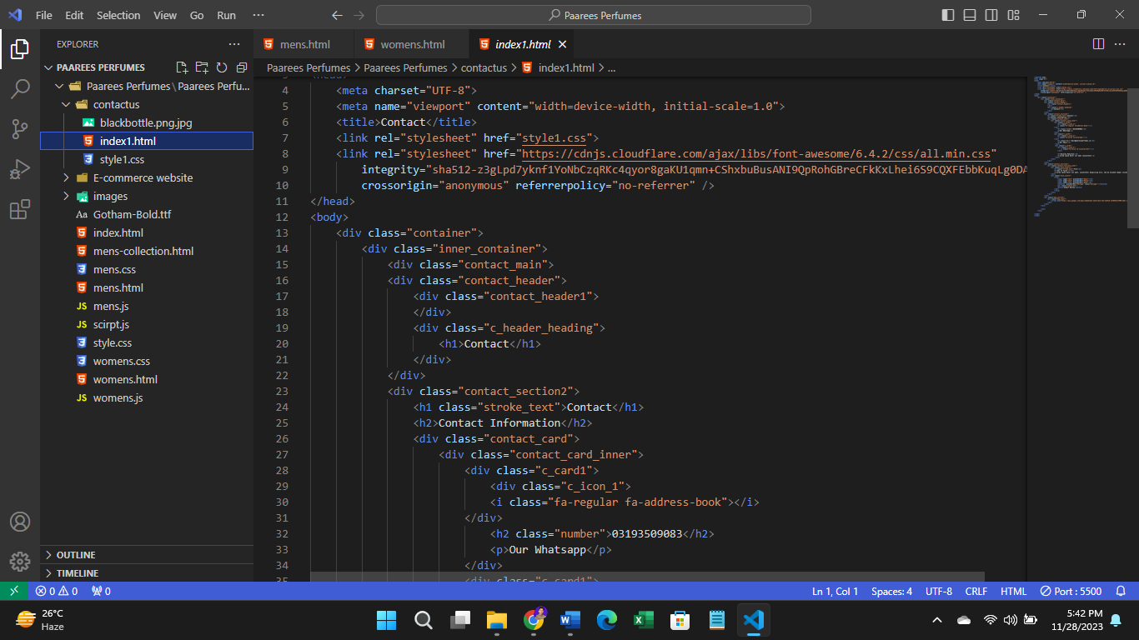



*CONTACT PAGE SOURCE CODE*



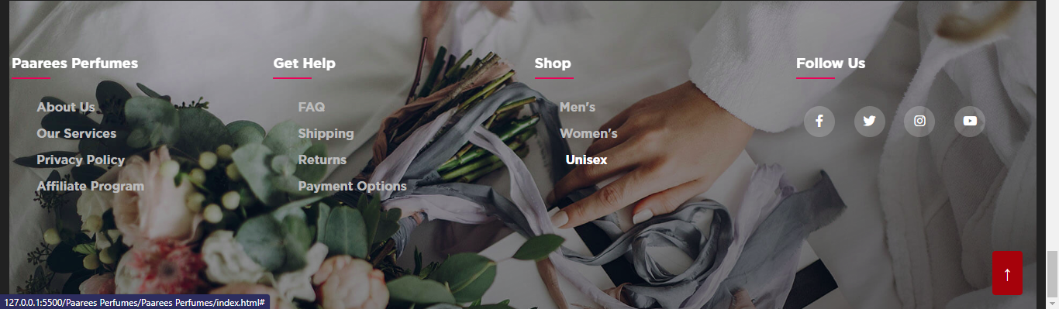***THE FOOTER***

***FOOTER SOURCE*** *CODE*



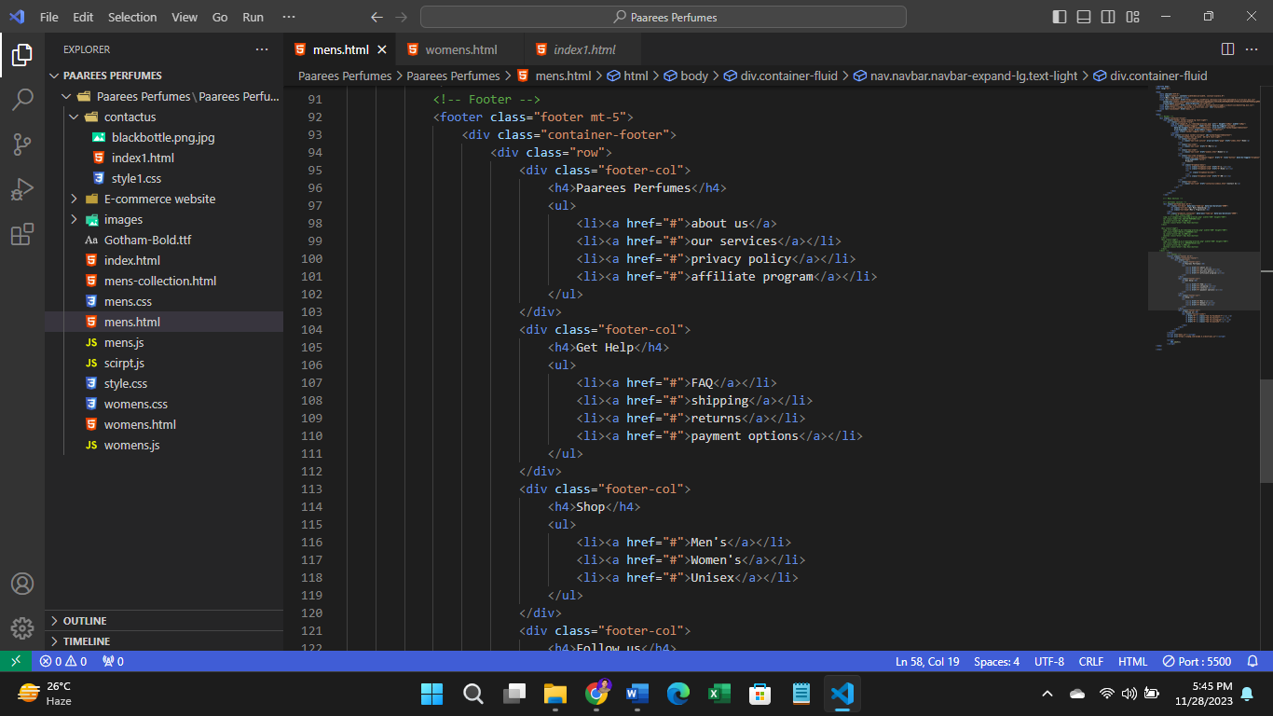



***PROJECT TASK SHEET***

|  |  |  |
| --- | --- | --- |
| **SHAYAN JUNAID** | | **PROGRESS** |
| ☐ | *Made a Prototype of a website* | 100% |
| ☐ | *Made a Structure of the website with HTML* | 100% |
| ☐ | *Put the Validations to the form using HTML Patterns* | 100% |
| ☐ | *Find and Fixed the Bugs* | 100% |
| ☐ | *Lead the project* | 100% |
| ☐ | *Code the website* | 80% |
| ☐ | *Graphic Designing work* | 100% |
| ☐ | *Scripting* | 100% |
| ☐ | *Documentation* | 100% |
|  |  |  |
| ***HASNAIN*** | | **PROGRESS** |
| ☐ | *Code the website* | 30% |
| ☐ | *Find the Products that relates to our topic to add it on to the e-project* | 100% |
| ☐ | *Find the different images of our topic.* | 100% |
|  |  |  |



